Database Management for Retail Application

**--QUERIES**

_____________________________________________________________________________________

**--Query1**

**--Find how many customers are there group by category**

SELECT Customer_Type, count(Customer_Type) as Total

FROM anra.customer

GROUP BY Customer_Type;

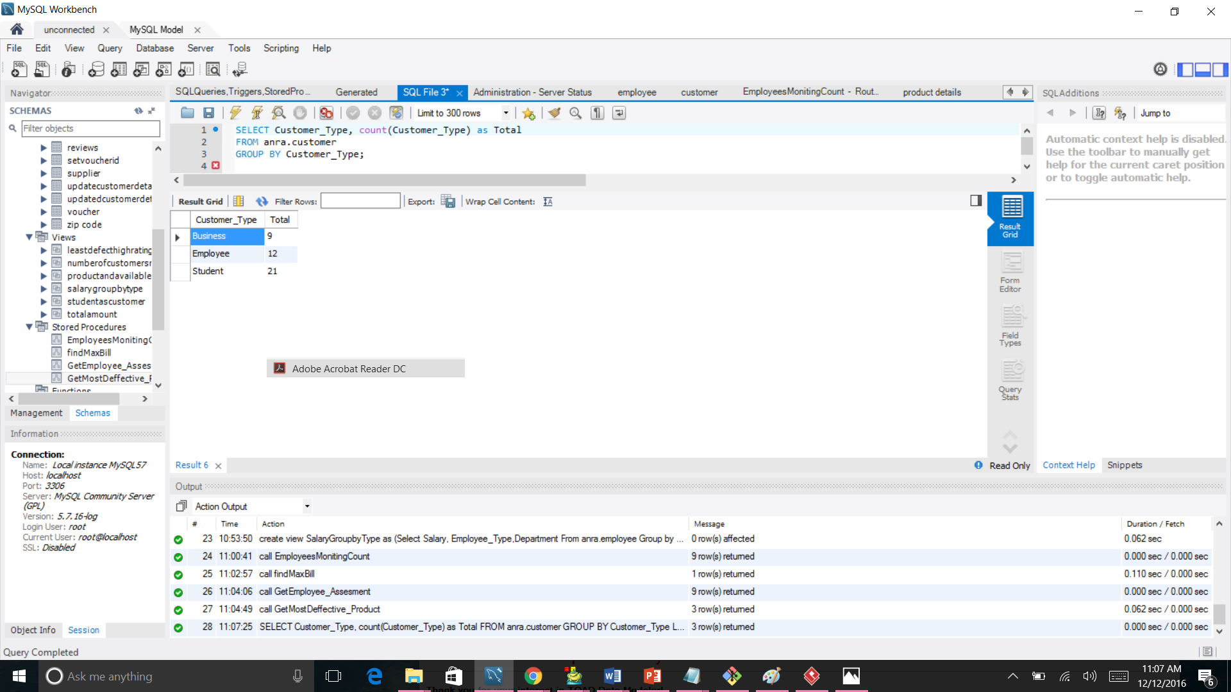

**--Query2**

**--Find 2 appartments whose name is emerald or their id is 11003**

SELECT Address_ID, Appartment_Name, Zipcode_ID

FROM anra.address

WHERE (Appartment_Name= 'Emerald' OR Zipcode_ID = '11003')

ORDER BY Zipcode_ID DESC

Limit 2;

**--Query3**

**--Find the supplied product count and their group for each product**

select anra.supplier.Supplier_ID,anra.supplier.Supplier_Name, Count(anra.product.Group_ID) AS `Product Count`, anra.`product group`.Group_Name

from

anra.supplier

inner join

anra.product

on anra.supplier.Supplier_ID=anra.product.Supplier_ID

inner join

anra.`product group`

on anra.product.Group_ID=anra.`product group`.Group_ID

Group by Supplier_ID Asc

**--Query4**

**--Total number of orders to be shipped immediate and is partially Shipped**

SELECT Order_ID, Order_Date,`Status`,count(Order_ID) as Total

FROM anra.orders

WHERE (Shippent_Duration= 'Immediate' and`Status`='Partially Shipped')

ORDER BY Order_ID DESC;

**--Query5**

**--List of products by department which has high defect%**

SELECT anra.reviews.Product_ID,anra.product.Product_Name,

MAX(anra.reviews.`Defect%`) As `Defect%`, anra.`product group`.Group_Name

from

anra.reviews

inner join

anra.product

on anra.reviews.Product_ID=anra.product.Product_ID

inner join

anra.`product group`

on anra.product.Group_ID=anra.`product group`.Group_ID

Group by `product group`.Group_ID

**--Query6**

**--Total amount of revenue earned with respect to their purchasing modes**

Select count(Payment_Mode) As Total_Cutomers, anra.payment.Payment_Mode,Sum(anra.bill.Amount_Paid)

As Total_Amount

from anra.payment

inner join

anra.bill

on anra.payment.Payment_ID=anra.bill.Payment_ID

group by Payment_Mode

**--Query7**

**--Find The quantity of products available whose status is in progress and shipment duration is immediate**

SELECT anra.product.Product_Name,anra.product.Available_Number,`order product`.Quantity,orders.Order_Date, orders.`Status`,orders.Shippent_Duration

from

anra.orders

inner join

anra.`order product`

on anra.orders.Order_ID=anra.`order product`.Order_ID

inner join

anra.product

on anra.`order product`.Product_ID=anra.product.Product_ID

where

orders.`Status`='In Progress' and orders.Shippent_Duration='Immediate';

**--Query8**

**--Find the names and defect% order by defect%**

SELECT Product_Name,`Defect%`

FROM anra.product

INNER JOIN anra.reviews

ON anra.reviews.Product_ID=anra.product.Product_ID

ORDER BY `Defect%` Desc;

**--Query9**

**--Find Customers payment ID,mode, vocher applied and their visit number**

SELECT anra.bill.Voucher_id, anra.payment.Payment_ID, anra.payment.Payment_Mode, anra.payment.Visit_Number

FROM anra.bill,anra.payment

WHERE anra.payment.Payment_ID=anra.bill.Payment_ID

AND anra.bill.Amount_Paid> 1000;

**--Query10**

**--Find product and their respective colour**

SELECT Product_Name, Colour

FROM anra.`product details`

INNER JOIN anra.product

ON anra.`product details`.Product_ID=anra.product.Product_ID order by colour

**--Query11**

**--Find the product Names their respective groups**

SELECT

Group_Name, Product_Name

FROM anra.`product group`

INNER JOIN anra.product

ON anra.`product group`.Group_ID=anra.product.Group_ID Order by Group_Name

**--Query12**

**--Find Total salaries payed to each employee type**

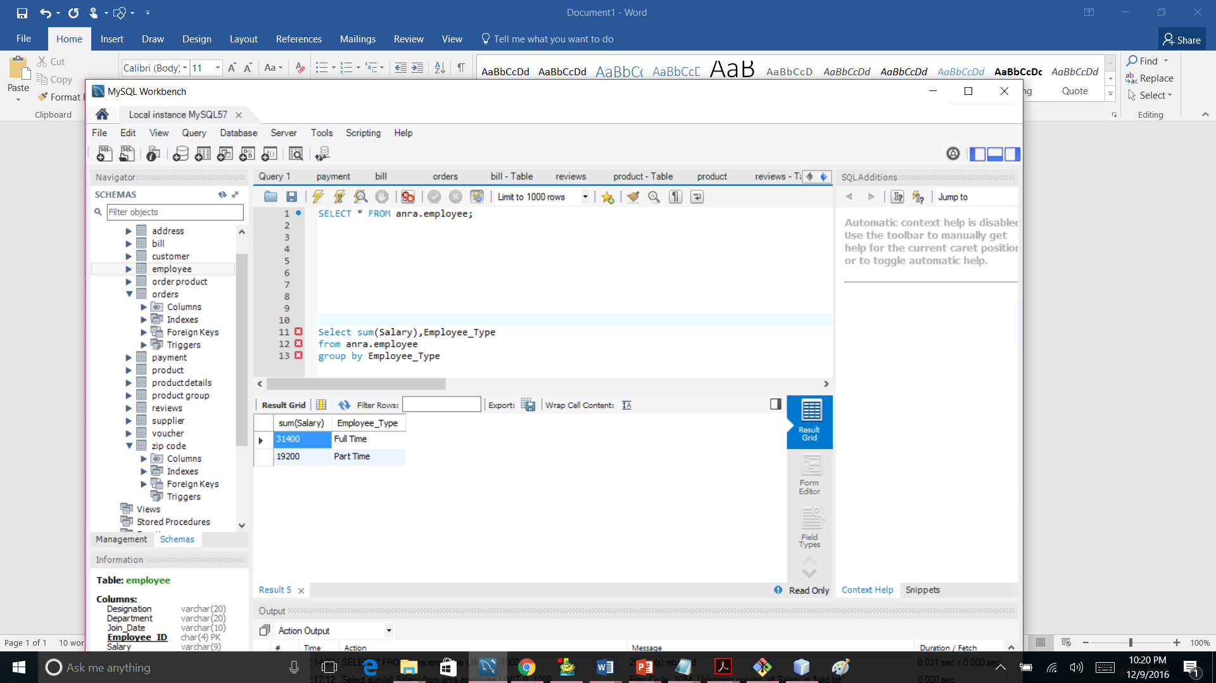

**--Query13**

**--Find Maximum salaries payed to each employee type**

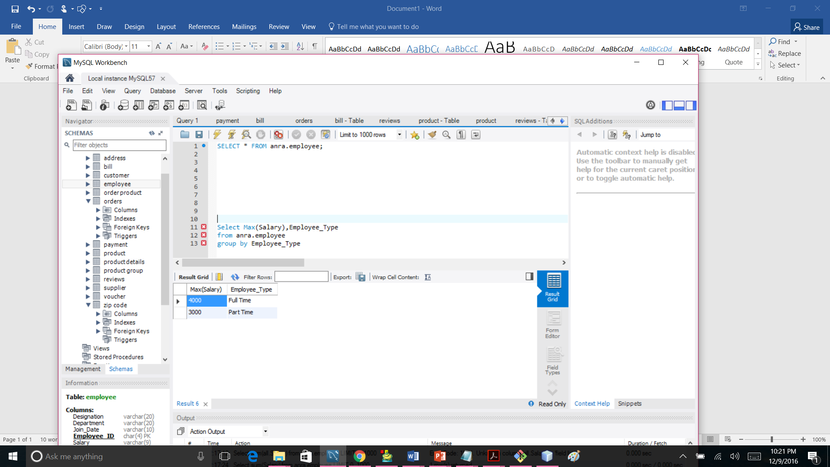

**TRIGGERS**

_____________________________________________________________________________________

**--Trigger1**

**--Find Customer name and updated time on customers table**

create table

UpdateCustomerDetails

(Customer_id int, First_Name varchar(20), update_time Datetime)

delimiter \\

create trigger UpdateCustomerDetails_trigger

after update on customer

for each row

begin

declare new_date datetime;

set new_date=now();

insert into UpdateCustomerDetails(Customer_id,First_Name,update_time)

values(old.Customer_ID,old.First_Name, new_date);

end \\

--when customers details are updated the trigger is set

update customer set Email_Address='naynaa@gmail.com'

where Customer_ID=10000

--updates can be seen in the newly created table

select * from UpdateCustomerDetails

**--Trigger2**

**--Find the newly changed colour for the product**

Create table

AddedProductColour

(Product_id char(5), Colour varchar(20))

delimiter \\

create trigger AddedProductColour_trigger

after update on anra.`product details`

for each row

begin

insert into AddedProductColour(Product_id, Colour )

values(old.Product_id,Colour);

end \\

**--Stored_Procedures**

_____________________________________________________________________________________

**--1**

**--Stored procedure to find most deffective product from each product group**

call GetMostDeffective_Product()

delimiter//

Create Procedure GetMostDeffective_Product()

Begin

SELECT anra.reviews.Product_ID,anra.product.Product_Name,MAX(anra.reviews.`Defect%`) As `Defect%`, anra.`product group`.Group_Name

from

anra.reviews

inner join

anra.product

on anra.reviews.Product_ID=anra.product.Product_ID

inner join

anra.`product group`

on anra.product.Group_ID=anra.`product group`.Group_ID

Group by `product group`.Group_Name

end//

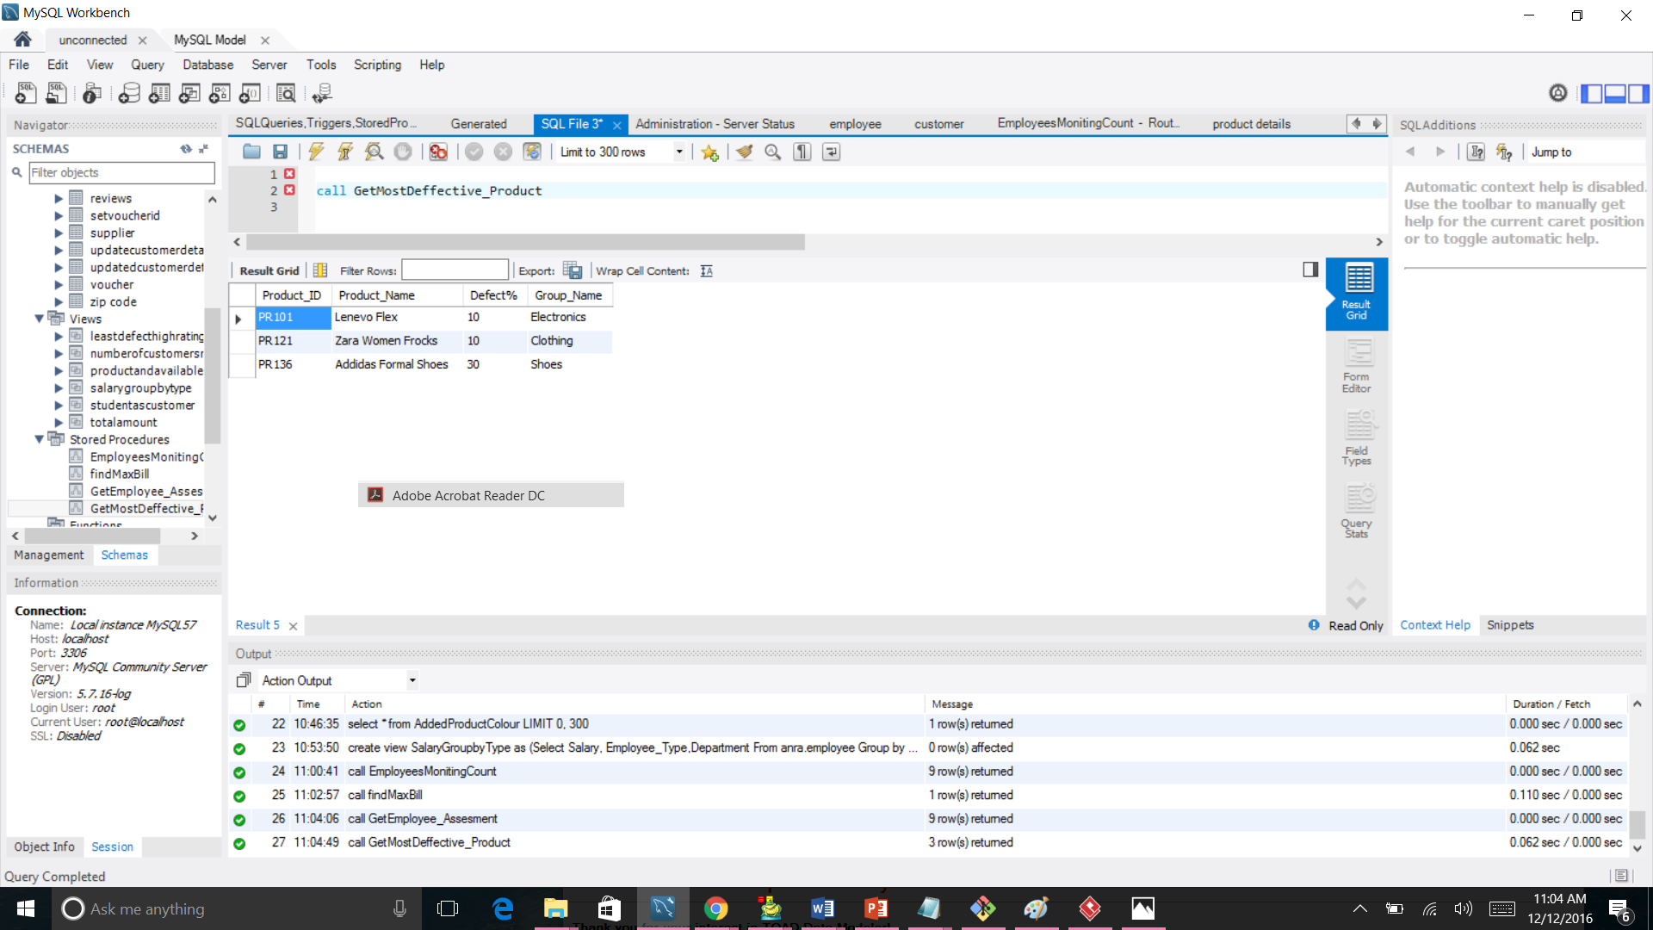

**--2**

**--Stored procedure for employee assesment**

call GetEmployee_Assesment ()

delimiter//

Create Procedure GetEmployee_Assesment ()

Begin

Select count(anra.customer.Customer_ID) as Total_Cutomers ,anra.customer.Employee_ID,anra.employee.Designation,Salary

from anra.customer

Inner Join

anra.employee

on

anra.employee.Employee_ID=anra.customer.Employee_ID

group by Employee_ID

order by count(anra.customer.Customer_ID) ;

end//

**--3**

**--Stored procedure to find customer details of highest Amount_Paid**

call findMaxBill()

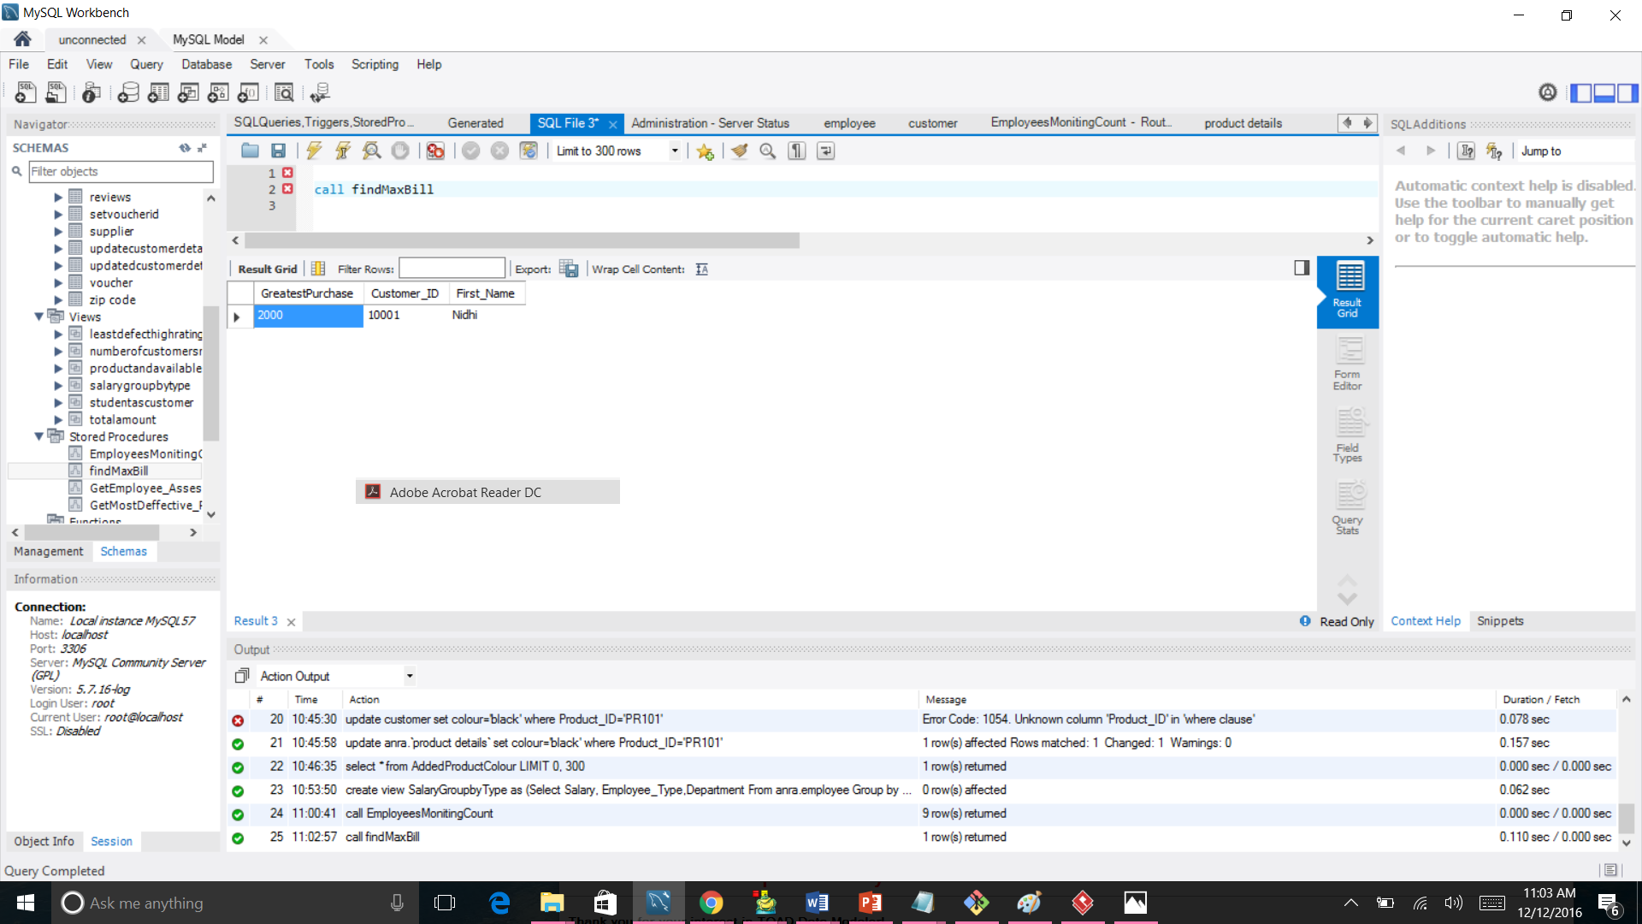

delimiter//

Create Procedure findMaxBill()

Begin

select Max(anra.bill.Amount_Paid) As GreatestPurchase, anra.customer.Customer_ID,anra.customer.First_Name from anra.bill

inner join

anra.payment

on anra.payment.Payment_ID=anra.bill.Payment_ID

inner join

anra.Customer

on anra.payment.Customer_ID=anra.customer.Customer_ID;

end//

**--4**

**-- Call EmployeesMonitingCount()**

CREATE DEFINER=`root`@`localhost` PROCEDURE `EmployeesMonitingCount`()

BEGIN

Select count(anra.customer.Customer_ID) as Total_Customers, anra.customer.Employee_ID,anra.employee.Designation

From anra.customer

Inner Join

anra.employee

on anra.employee.Employee_ID=anra.customer.Employee_ID

group by anra.employee.Employee_ID

order by count(anra.customer.Customer_ID) desc;

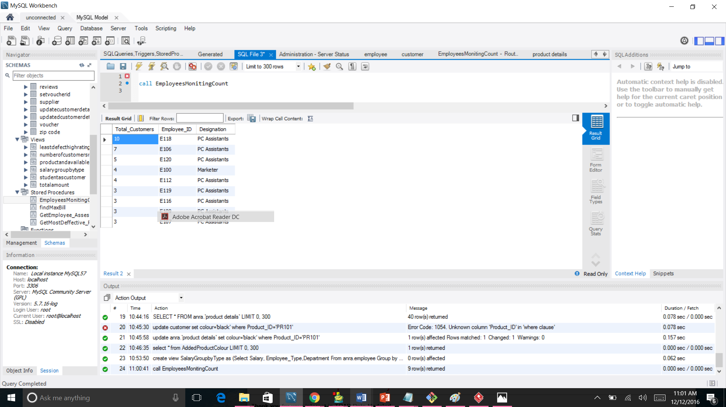

END

**--Views**

______________________________________________________________________________**_______--1**

**--Student as customer views**

create view StudentAsCustomer as ( select * from customer where Customer_Type = 'Student')

**--2**

**--Product details with minimum defect% and high rating**

create view LeastDefectHighRating as

(select product.Product_Name, min(reviews.`Defect%`), max(reviews.Quality_Rating)

from anra.reviews

inner join

anra.product

on anra.reviews.Product_ID=anra.product.Product_ID)

**--3**

**--Products and the colours available**

create view ProductandAvailableColours as

(SELECT Product_Name, Colour

FROM anra.`product details`

INNER JOIN anra.product

ON anra.`product details`.Product_ID=anra.product.Product_ID order by colour)

**--4**

**--Distinct employee departments whose salary is greater than 1200 limit to 4**

create view DistinctEmployeeDepartments as

(Select DISTINCT anra.employee.Designation,anra.employee.Employee_Name,anra.employee.Department

From anra.employee

Where anra.employee.salary>1200 limit 4)

**--5**

**--Create view TotalAmount as Total amount of revenue earned with respect to their purchasing modes**

create view as totalamount

(Select count(Payment_Mode) As Total_Cutomers, anra.payment.Payment_Mode,Sum(anra.bill.Amount_Paid)

As Total_Amount

from anra.payment

inner join

anra.bill

on anra.payment.Payment_ID=anra.bill.Payment_ID

group by Payment_Mode)

**--6**

**--Create view to know the employee designation and id and total number of customers monitored by each employee in descending order**

create view NumberOfCustomersMonitered as

(Select count(anra.customer.Customer_ID) as Total_Customers, anra.customer.Emploee_ID,anra.emploee.Designation

From anra.customer

Inner Join

anra.employee

on anra.employee.Employee_ID=anra.customer.Employee_ID

group by Employee_ID

order by count(anra.customers.Customer_ID) desc)

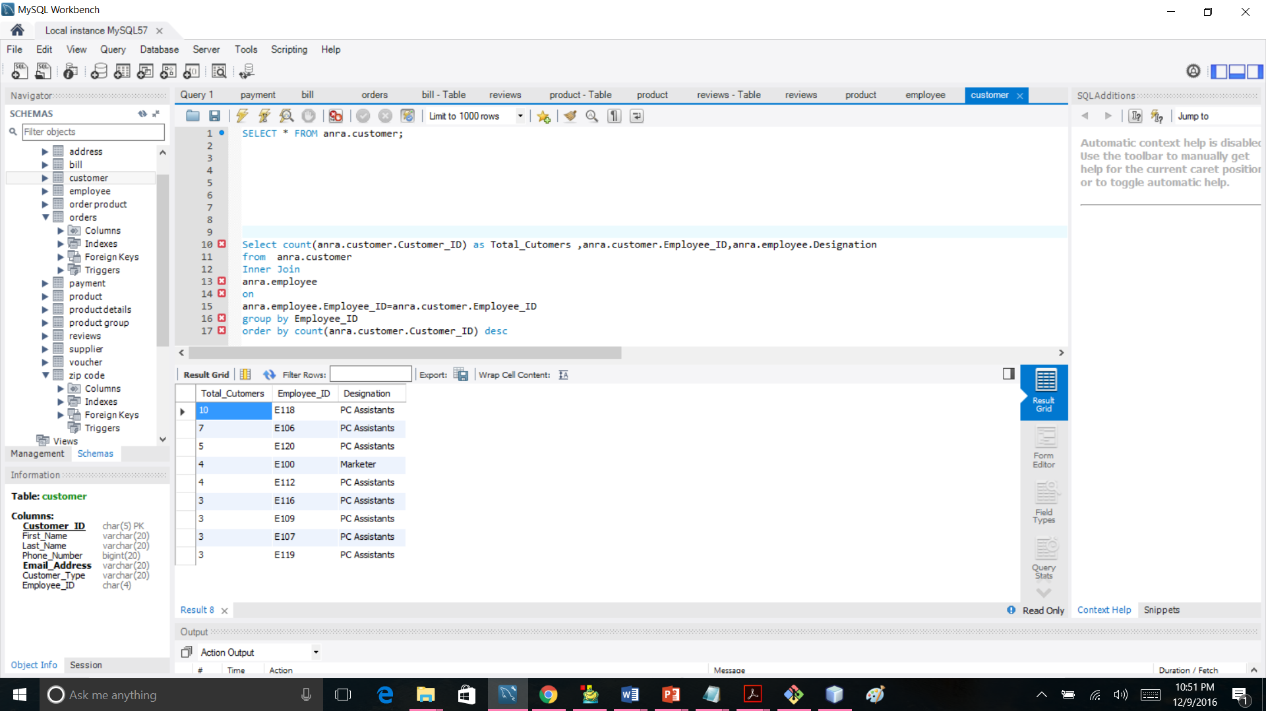

**--7**

**--View Salary of employee group by type and department**

create view SalaryGroupbyType as

(Select Salary, Employee_Type,Department

From anra.employee

Group by Employee_Type,Department)

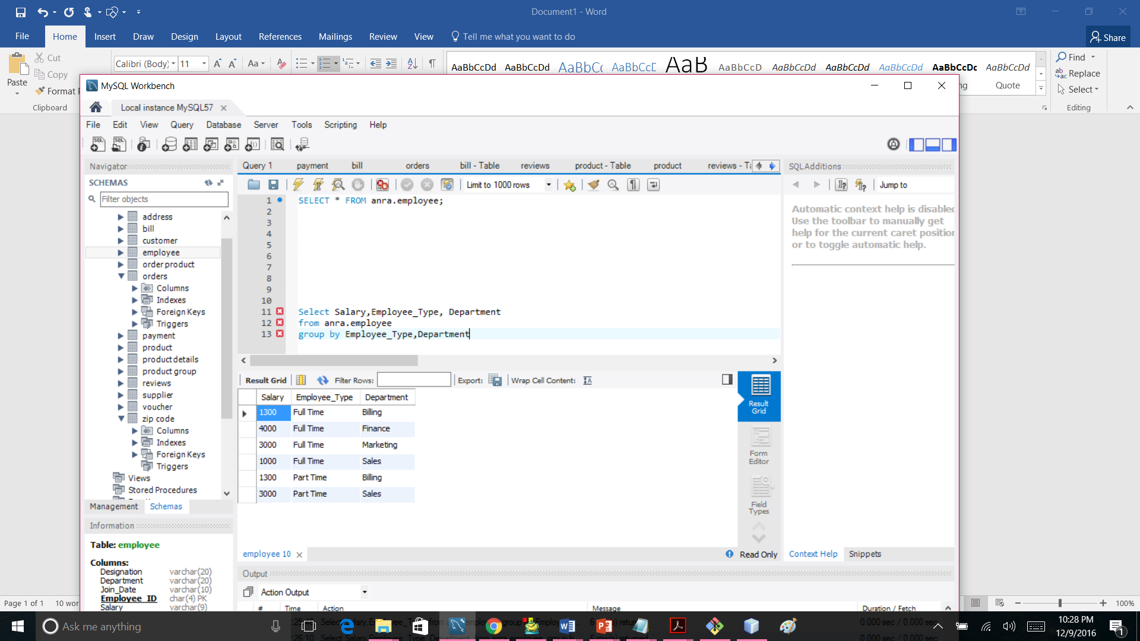

**--8**

**-- Find The quantity of products available whose status is in progress and shipment duration is immediate**

create view OrderStatusandAvailableQuantity as

(SELECT anra.product.Product_Name,anra.product.Available_Number,`order product`.Quantity,orders.Order_Date, orders.`Status`,orders.Shippent_Duration

from

anra.orders

inner join

anra.`order product`

on anra.orders.Order_ID=anra.`order product`.Order_ID

inner join

anra.product

on anra.`order product`.Product_ID=anra.product.Product_ID

where

orders.`Status`='In Progress' and orders.Shippent_Duration='Immediate') 